SAMARITANS IN SPAIN NEWSLETTER FEBRUARY 2020
Hello Everyone,
We look forward to seeing many of you at the pre-Valentines event at Punta Prima this coming Saturday – details as above.
For ALL OUR LISTENERS within easy reach of Punta Prima please remember that we have our next group meeting and afternoon tea at the Drop In on Wednesday 12th February 2.30pm. It is another opportunity to meet other volunteers and welcome any newbies.
There has been plenty going on this past month. Many thanks to Les Holloway and Brian Myles for the refurbishment of the Charity Shop at Punta Marina. It looks great!
Recently Listener Linda Stewart very kindly facilitated contacts for us with the airline Jet2 who are now donating to Samaritans each month numerous lost property items that have been unclaimed within the time allowed. Other airlines may now do the same! We have a number of items also being auctioned via Lumsden’s auction house in Formentera de Segura where we have our charity unit.
We had an awareness stand at a charities fair at Viajes Playa Flamenca at the end of last month and have given talks at an expat community meeting in Dolores (near Elche) and ADAPT (association of English speakers Torrevieja) in Lo Pagan (San Pedro).
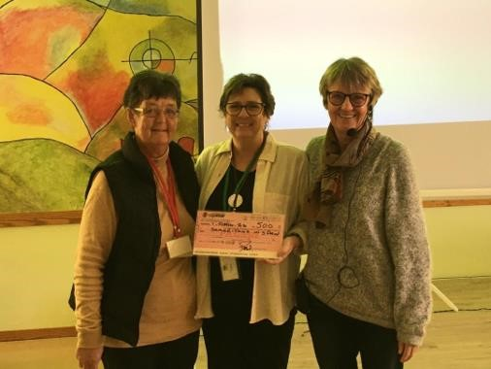
ADAPT have generously donated 500€ to Samaritans in Spain – the presentation was made by organisers Celia (L) and Jane Cronin (R).

WWW.EXPOTORREVIEJA.COM
We are now preparing for our attendance at the Torrevieja Expo (for Clubs and Associations) to be held at the International Auditorium Torrevieja, 10am to 3pm on Saturday 7th and Sunday 8th March. Entrance is Free. For more info please visit the webpage.

Other forthcoming events and dates for your diary:
Spring Fayre at Punta Marina Centre Saturday 2nd May
Samaritans Costa Blanca Pub Quiz Championship 17th – 23rd May
(please contact Trustee Donna Williams for more details)

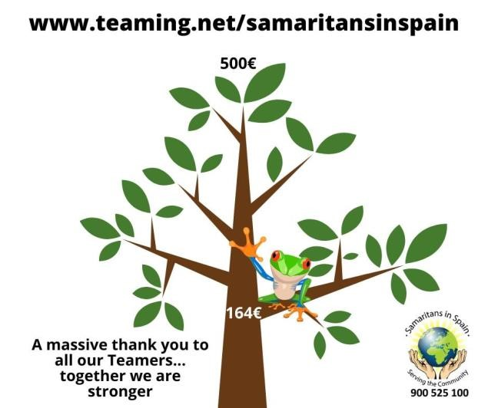

Annual Samaritans in Spain All Volunteers Meeting 2020 will be held on Saturday 29th February at Punta Prima. This is a fantastic opportunity for everyone to come together, network and share ideas and opinions as well as have some social interaction.
The event will be held at the Torre Joven Hotel on the N332 opposite the CC Punta Marina where the Samaritans centre is located. (hoteltorrejoven.com). Volunteers from satellites who cannot visit in an easy day trip may book a room at the hotel and claim for this along with travel expenses. (Please contact the
Centre Managers on dropinspainsams@gmail.com or 966 79 82 30)
The formal meeting is held mid-afternoon and any visitors are welcome to visit duty volunteers at the centre beforehand on that same day. The Drop In and Shop will both be open from 10am.
Prior to the event the Board of Trustees will issue electronically the 2019 annual report and strategy and objectives for the coming year along with an update Welcome to Samaritans brief plus the agenda for the formal meeting. This will take place in a reception room on the ground floor of the hotel from 3.30pm. The Centre Managers will chair the meeting this year and there will be a Q & A session.
Partners and friends do not attend the formal meeting however they are welcome to use the hotel bar, TV lounge or games room and join us from 5pm, when we will have live music from a local entertainer and drinks and tapas though until 8pm. For those wishing to eat later, or staying overnight, there are plenty of local restaurants, and shops, and beach, within walking distance also.
Previous Annual Reports, past Newsletters, details of policies and procedures etc are all held on the Volunteers Area of our website www.samaritansinspain.com which is also undergoing a revamp for
2020. Please remember to check for updates and follow
Samaritans In Spain on Facebook for details of events

Lastly:
It with great sadness that we have to announce that Mandy Crawford White, one of our longest serving and most loyal shop volunteers died suddenly on 3rd Feb at the tender age of 65. Our thoughts are with her husband John and the rest of her family.

Lynda Brettle, President – Samaritans In Spain lynda.spainsams@gmail.com

