SAMARITANS IN SPAIN NEWSLETTER JANUARY 2020
Hello Everyone

Welcome to the first Newsletter of the new decade! Hope you have all enjoyed a good Christmas.
We kicked off the New Year with a Saturday 3 Kings Special at the Punta Marina centre which raised over 200 euro in additional funds from the tombola and cakes stalls so well done to all who had supported the event. The Charity Shop also has a fresh layout so please take a look as you may now spot some extra bargains!
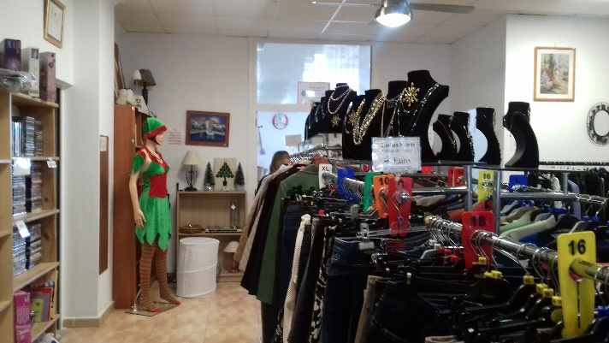

We all had an enjoyable pre-Christmas lunch held on 14th December – it was great to see so many volunteers mixing and mingling………. 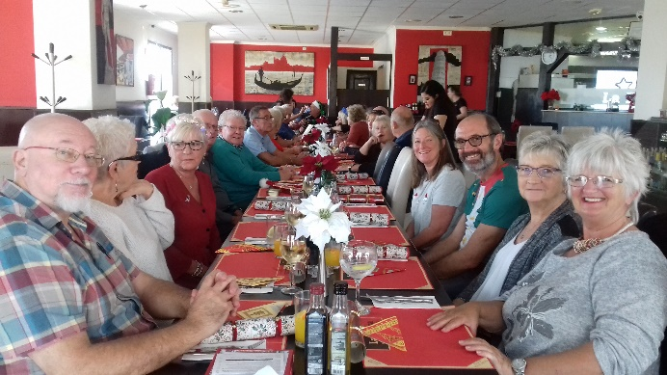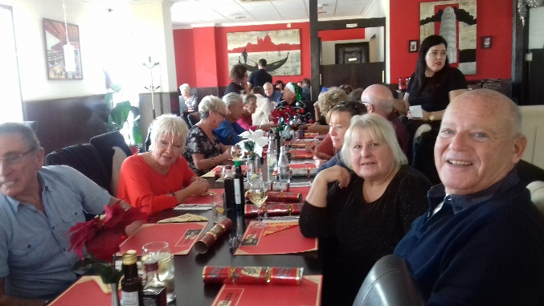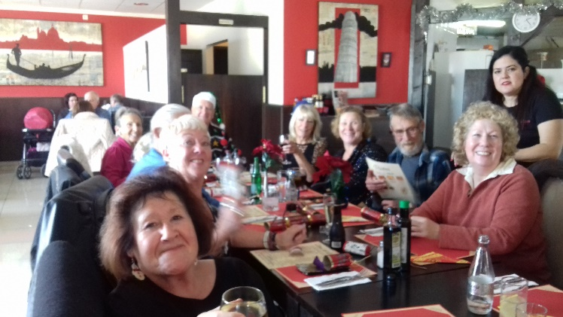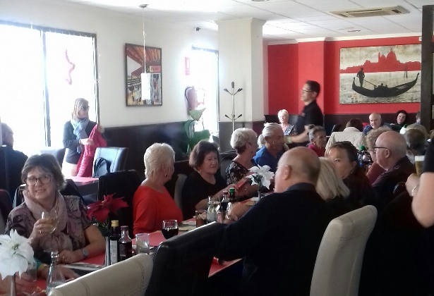
Arrivals and Departures
At the end of 2019 we were sorry to say farewell to our patron Dave Bull, who has returned to UK for family reasons, and also our Punta Marina Listeners Anki Stegland and Mary Johnson – we hope both may return as and when they are able. We are now pleased to welcome new volunteer James Blunt to our Lumsdens Unit in Formentera.
Satellite Teams
Our nearest remote -working Listener team based at Urb La Marina are celebrating their first year with a small get together on 6th Feb. Our priority for 2020 is to help all our other new teams who are not within an easy drive of headquarters with additional mentoring and other support. Meanwhile please remember if anyone has any concerns please do not hesitate to contact the Centre Managers 10am to 6pm Mon to Sat at dropin.spainsams@gmail.com.

Our Annual Samaritans in Spain All Volunteers Meeting 2020 will be held on Saturday 29th February at Punta Prima. This is a fantastic opportunity for everyone to come together, network and share ideas and opinions as well as have some social interaction. The formal meeting is held mid-afternoon when the Board of Trustees share the annual report and strategy and objectives for the coming year and there is an open question and answer session. It will be followed by a social event in the early evening, to which partners are also invited, and satellite volunteers are also welcome to come into the centre for familiarisation as well on the Saturday morning or arrange other meetings in the margins of the event.
Final details about the venue (usually withing walking distance or at the hotel) and other information will follow by email in advance and we hope as many volunteers as possible (Listeners and Non Listeners) will attend from Punta Prima AND that each satellite will be able to send one or two members from their local team. Travel expenses and one night’s accommodation at the Torre Joven hotel opposite the Samaritans centre is payable only for those who cannot make a return day trip to Punta Prima. Volunteers are kindly asked to make their own travel arrangements room booking at hoteltorrejoven.com and submit an expense claim on arrival. If there is further information you would like please contact the Centre Managers at dropin.spainsams@gmail.com. Thank you.
Annual Reports, past Newsletters, details of policies and procedures are all held on the Volunteers Area of our website www.samaritansinspain.com which is also undergoing a revamp for 2020. Please remember to check for updates and follow Samaritans In Spain on Facebook for details of events
SUPPORT FOR OUR VOLUNTEERS
BREXIT
As we all know the UK is now due to leave the EU on 31st January. Before Christmas heads of local charities and other expatriate organisations were invited to a meeting in Alicante with the new British Ambassador Hugh Elliott and the Consulate staff where reassurance was given that anyone who still needs to get their paperwork in order for residency etc still has until the end of this year to complete the process. So please do not leave it too late – everything must be in place before 31st Dec 2020. There have been numerous reports of “fake news” within the expat community and also within the local Spanish administration leading to wrong information being shared. For the latest official guidance please always refer to https://www.gov.uk/brexit and follow the official British Embassy Facebook Page which is Brits in Spain.

BEGINNERS SPANISH AND CONFIDENCE BUILDIING
Will start again at Punta Marina on Weds 29th January and run for 10 weeks with the final sessions on Weds 1st April before Easter.
1030 – 1130am Beginners (basic survival, everyday tasks)
12 – 1pm Continuation Group (talking in the present, past, future)

We can also offer ad hoc small group sessions in
EMOTIONAL RESILIENCE TRAINING
Stress management and dealing with difficult people, personal boundaries and “bouncing back”– half day workshop
ESSENTIAL MANAGEMENT SKILLS
Personal organisation, time management, delegation, priorities, communication skills etc – 1 to 2 days

And we recommend for all non-Listener / Shop volunteers
SHORT AWARENESS BRIEFING ABOUT THE LISTENER ROLE to give you an understanding of the service that you help us provide.
All these sessions may be run at Punta Prima Drop-In or another local venue. If you are interested in participating please give your details to the Centre Managers by the end of January and we will aim to organise suitable dates for the training to be delivered in the Spring. If partners, friends, neighbours also wish to attend please add their names and contact details to the list held with the Centre Managers. All of the above sessions are FREE to serving volunteers. Please note we ask others to make a small donation to Samaritans.
Finally,
Spread the word about Samaritans in Spain – it could save a life! Please can everyone, regardless of the role you play at Samaritans, be aware of how members of the public may contact us when they themselves or people they know are in distress. They do not have to be suicidal. They might just be lonely, depressed, angry or ill and frightened. It is FREEphone 900 525 100 and easy to remember. You never know when you might just be able to help someone by giving out that number or our email pat@samaritansinspain.com.

Thank you very much and best wishes to you all for the year ahead.

Lynda Brettle
President, Samaritans In Spain
lynda.spainspams@gmal.com

